ABSTRACT

Underwater image processing technology is an intelligent research field with great potential to help researchers better detect the underwater environment. Underwater image processing technology has been widely used in many fields, such as underwater microscopic inspection, underwater target recognition, terrain scanning and so on. However, due to the influence of absorption and scattering, images taken underwater are usually degraded, which will limit the display and analysis of underwater images. In order to improve the quality of underwater images, domestic and foreign scholars have conducted in-depth research on underwater image processing methods. The existing underwater image processing methods can be divided into two categories: (1) traditional underwater image processing methods (2) underwater image processing methods based on deep learning. This paper introduces the underwater imaging model, analyzes the reasons for the degradation of underwater image visual quality, analyzes and summarizes the research status of the two types of methods, and introduces several commonly used underwater image objective quality evaluation indicators. Finally, the advantages and disadvantages of various methods are summarized and discussed, and the future development direction is prospected.

Key words: Image processing;underwater imaging;image enhancement;image restoration

1 Introduction

The visual quality of underwater images plays an important role in many marine engineering applications and scientific research, such as automatic detection and recognition of fish and plankton, and underwater saliency detection. However, due to the selective absorption and scattering of light in the process of underwater propagation, underwater images usually show color cast and low contrast. Therefore, underwater image enhancement technology is needed in scientific research and computer applications.

According to the Jaffe-McGlamery underwater imaging model [1], as shown in Figure 1, the underwater image can be expressed as the addition of 3 components, namely  （1）

Among them, ET represents the underwater image captured by the imaging device; Ed is the direct attenuation component, which represents the light reflected and not scattered by the underwater object; Ef represents the forward scattered component, which means that the reflected light is submerged in the process of reaching the imaging device. The influence of suspended particles produces light at a small angle; Eb is the backscattered component, which means the reflected light from the surrounding environment is scattered by suspended particles in water and enters the imaging device.

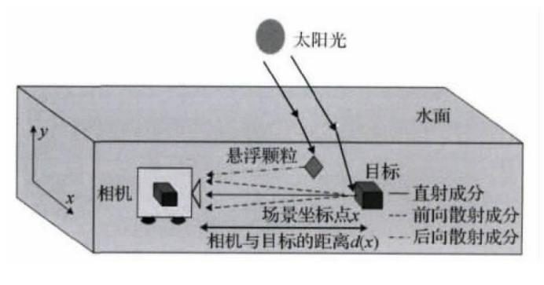

Fig. 1. Underwater optical imaging model

The absorption of light by water also seriously affects the quality of underwater images, causing color cast in underwater images. The Lambert-Beer empirical law states that the propagation of light is affected by the propagation distance and the medium passing through it. Figure 2 shows the absorption of light of different wavelengths in water. In view of the impact of light scattering and scattering factors on underwater images and the problem of image color distortion, researchers have proposed and continuously improved the sharpening algorithm to improve image quality. This article summarizes some of these methods.

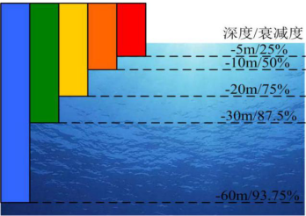

Figure 2: Schematic diagram of light absorption

2 Traditional Underwater Image Processing Method

Existing underwater image sharpening methods can be roughly divided into traditional methods and deep learning-based methods, among which traditional methods can continue to be divided into imaging model-based image restoration methods and underwater image enhancement methods. The imaging model-based image restoration method aims at the degradation process of underwater images, and constructs an imaging model suitable for underwater environment to restore clear images. The underwater image enhancement method mainly improves the brightness and color of the image by changing the intensity value of each color channel of the underwater image, thereby improving the image quality.

2.1 Underwater Image Restoration Method

In recent years, researchers have devoted themselves to removing haze from a single image. The algorithm is based on the large scattering model proposed by Koschmieder [2] and further derived by Narasimhan and Nayar [3]. Mathematically, the atmospheric scattering model can be defined as:

 （2）

Among them, x represents the pixel index, and I(x) and J(x) represent the image of the foggy scene and the true radiation value of the scene respectively. A represents the global atmospheric light, and t(x) is the transmittance of the medium. The medium transmittance function t(x) can be further expressed as:

 （3）

Where β is the atmospheric scattering coefficient, and d(x) represents the depth of the scene, that is, the distance between the target object and the imaging device.

Due to the many similarities between the decline in underwater image quality and the decline in foggy image quality, the researchers integrated the relevant characteristics of the underwater environment on the basis of the atmospheric scattering model to estimate the model parameters, and then use the model to restore Underwater image.

In the process of estimating model parameters, certain prior information is needed. The most famous one is the Dark Channel Prior (DCP) proposed by He et al. [4]. The dark channel prior is a statistically based method. A priori, it is found in the statistics of a large number of clear outdoor images that the intensity of at least one color channel of a clear outdoor image in a non-sky area is close to zero. The dark channel a priori has been proven to be used to effectively estimate the global atmospheric light and atmospheric transmittance from a single image, so as to restore the real image of the foggy scene with the help of the atmospheric scattering model. Therefore, many researchers have proposed a variety of underwater image restoration methods based on DCP. For example, Drews Jr et al. proposed an Underwater Dark Channel Prior (UDCP) [5] based on the traditional dark channel prior. This method believes that the visual information of underwater images is mainly retained in the blue channel and the green channel. In, because the red channel has serious attenuation. UDCP estimates the projection rate and global background light on the green and blue channels by excluding the red channel. In the task of underwater image restoration, it can achieve better visual effects than traditional DCP methods. Peng et al. proposed a generalized dark channel prior (GDCP) [6]. This method takes into account that due to the difference in haze, the transmittance is often overestimated or underestimated, and due to the acquisition process of underwater images It is often accompanied by the use of artificial light sources, and the traditional DCP method is prone to make errors in the estimation of the scene depth. In order to solve the above two problems, the GDCP method uses the method of estimating the depth of the scene based on the scene gradient. This method is based on the observation of underwater images, that is, the nearby scenes often have rich detailed information, and the distant scenes are relatively smooth. GDCP first performs gradient calculation on the original image, and then performs morphological expansion processing on the gradient map to obtain a rough depth map. By performing linear regression calculation on the three channel pixels, it is possible to obtain which channels are depth-related channels. Further optimize the estimated depth map. On the basis of accurately estimating the depth of the scene, the global background light and transmittance are further estimated, so as to restore the underwater image with the help of the imaging model. Peng and Cosman also proposed a method for estimating the depth of an underwater image scene, which is based on image blur and light absorption, and the estimated depth of field can be used to restore underwater images in the imaging model [7].

In addition to the priors related to DCP, other underwater image restoration works also provide useful priors. Galdran et al. proposed a priori method for the red channel to restore the contrast information of underwater images. This method compensates for the strong attenuation of red light in the water medium by inverting the red channel [8].

 （4）

Li et al. proposed an underwater image restoration method based on the principle of minimum information loss, which can restore natural image visual effects [9]. On this basis, a histogram distribution prior is proposed. Based on the histogram distribution prior, the contrast information of underwater images can be effectively enhanced, but it will cause some color deviation.

2.2 Underwater Image Enhancement Method

On the other hand, underwater image enhancement methods improve image quality by changing the intensity values of RGB color channels according to certain rules. Several traditional image enhancement methods aim to display more visual details by adjusting the histogram of the degraded image. For example, histogram equalization (HE) [10], contrast-limited adaptive histogram equalization (CLAHE), etc. [11]. However, for images with complex depth of field and uneven blurring, HE can hardly improve the local contrast of the image, resulting in excessive enhancement of the local area of the image and loss of detail information; and due to the over-compensation of the R channel, the close-up scenes show red tones. The color is distorted. The CLAHE algorithm was first applied in the field of medical imaging. In order to improve the processing speed of the algorithm, CLAHE uses linear interpolation to improve efficiency. Experiments have shown that the interpolation result hardly affects the effect of the algorithm.

In recent years, many single underwater image enhancement methods have been proposed. Iabal et al. proposed an unsupervised color correction method (UCM) based on color balance and histogram stretching to enhance underwater images [12]. In order to produce high-quality results, Fu et al. adopted a two-step image enhancement method. The first step is to correct the light attenuation in the underwater image, and then to enhance the contrast of the corrected result [13]. Liang et al. proposed a defogging method based on attenuation map-guided color correction and detail preservation to obtain high-contrast underwater images [14].

Ancuti et al. successively proposed a single image enhancement algorithm based on multi-scale fusion. First, two enhanced versions of the image are obtained from the original image by using white balance and contrast enhancement algorithms. In order to make the output image have good visibility, Ancuti chooses 3 weights to fuse the image: brightness weight, chroma weight and saliency Sexual weight [15]. Finally, a multi-scale fusion algorithm is used to eliminate artifacts introduced by image weights. Aiming at the fogged dark image, Ancuti et al. proposed dark image enhancement based on fusion, which can improve image contrast while effectively increasing image brightness, which is suitable for deep-sea dark image processing. In 2018, based on previous research, Ancuti et al. proposed an underwater image enhancement algorithm based on color balance and fusion strategies. In this algorithm, Ancuti innovatively proposed a color compensation mechanism based on the green channel, which has excellent robustness to images with various color casts.

On the other hand, computer vision applications have always been inspired and challenged by the high efficiency of human vision. Therefore, some image enhancement algorithms have received inspiration from biological systems. Most of these algorithms are inspired by the information processing mechanism or psychophysiological behavior of cells in each layer of the retina. Based on the color constancy theory, Land et al. further proposed the Retinex theory [16], and the theoretical model is shown in Figure 3. Retinex theory believes that the true color of an object is not affected by uneven illumination, but is determined by the reflectivity of the object to light of different wavelengths. In the field of image enhancement, the image enhancement method based on Retinex theory believes that an image can be decomposed into two parts: the illumination component and the reflection component. The task of image enhancement is to modify or remove the illumination component reasonably to obtain a better image visual effect.

 （5）

Where R represents the reflection component, L represents the illumination component, and I represents the image captured by the camera.

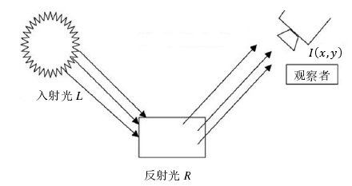

Figure 3: Schematic diagram of Retinex model

Some researchers have proposed some image enhancement algorithms by simulating the information processing mechanism of the retina. In the field of underwater image enhancement, Gao et al., inspired by the shape and function of the bony fish retina, proposed an underwater image enhancement model. The layer simulates the physiological functions of various cells in the retina to solve the problem of underwater image degradation caused by blur and uneven color shift [17]. The algorithm flow chart is shown in Figure 4.

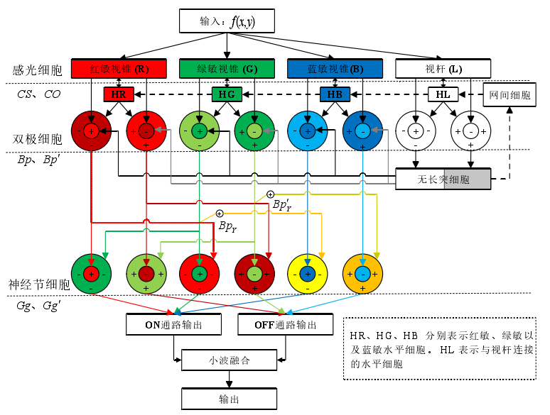

Figure 4: Image enhancement model based on the structure and function of the bony fish retina

The R, G, B and brightness components of the input color image are responded to by the corresponding photoreceptor cells. Then, through the regulation of horizontal cells, the output of photoreceptor cells is input into the center of the receptive field of bipolar cells, and the output of horizontal cells is input to the periphery of the receptive field of bipolar cells. The bipolar cells of the cone pathway also receive input from the bipolar cells of the rod pathway after being regulated by amacrine cells. The output of the bipolar cells is finally input to the receptive field of the gangliomonal antagonist cells, and finally the output is fused.

3 Underwater Image Enhancement Method Based on Deep Learning

With the popularity of GPUs, deep learning methods have become the most advanced solutions in the field of computer vision and have excellent performance. Li et al. proposed a water-generating confrontation network (WaterGAN) based on a two-stage strategy to eliminate color cast [18]. Similarly, UGAN such as Fabbri, which uses CycleGAN as a preprocessing method, reconstructs underwater images with poor visual quality based on relatively clear underwater images [19]. After that, the synthesized underwater images are used as training labels for adversarial training under supervision. In order to enhance underwater images in real time, Islam et al. proposed a supervised enhancement model called FUnIEGAN, whose training data was prepared using the same procedure suggested by Fabbri et al. [20]. In addition to the above GAN-based methods, there are many underwater image enhancement solutions based on Convolutional Neural Networks (CNN). For example, Li et al. proposed an underwater image enhancement convolutional neural network model based on underwater scene priors, called UWCNN. This model is an end-to-end method for underwater image formation models. The CNN architecture trained on the underwater scene of the previous underwater image [21].

4 Underwater Image Evaluation Index and Result Display

In order to evaluate the performance of underwater image processing methods, it is necessary to establish underwater image quality evaluation standards. According to whether there are subjective individuals involved in the evaluation process, underwater image quality evaluation methods can be divided into subjective evaluation methods and objective evaluation methods. Because different subjective individuals have different sensitivity to image brightness, hue, contrast, etc., in the subjective evaluation, different individuals have different evaluations of the same image. Therefore, in order to eliminate the influence of different subjective individuals on image ratings, subjective evaluation methods need to organize a large number of evaluators to evaluate underwater images, and calculate the average score of all evaluators. Since people are usually the ultimate recipients of images, subjective evaluation methods are closer to reality.

In order to make up for the shortcomings of subjective evaluation methods, researchers are committed to developing objective evaluation methods. According to whether there are reference images in the evaluation process, objective evaluation can be divided into full-reference evaluation and no-reference evaluation.

4.1 Objective Evaluation Index of Underwater Image

This section introduces two commonly used methods for underwater image quality evaluation, patch-based contrast quality index (PCQI) and UIQM (Underwater Image Quality Measure).

PCQI is an objective evaluation method to evaluate the degree of image contrast change. Different from other ratio quality models, the characteristic of this method is that when it is applied to a local area of an image, it can generate a local contrast quality map for predicting spatial local quality changes, thereby providing useful information about spatial local quality changes [22 ]. The PCQI method can decompose any image block into average intensity, signal intensity, and signal structure components, and then evaluate the degree of distortion of the image in different ways. Its mathematical expression is:  （6）

The UIQM evaluation index is one of the objective evaluation indexes for underwater restored images [23]. In view of the degradation mechanism and imaging characteristics of underwater images, this method uses color measurement (Underwater Image Colorfulness Measure, UICM), sharpness measurement (Underwater Image Sharpness Measure, UISM) and contrast measurement (Underwater Image Contrast Measure, UIConM) as underwater images. Basis for image quality assessment. The UIQM quality evaluation index is expressed as a linear combination of the above 3 measurement components, namely:

 （7）

In the formula, c1, c2 and c3 are weighting factors. The weighting factor is determined according to the specific situation. When evaluating the color deviation correction effect of the restored image, a larger weight value of the color measurement scale UICM needs to be assigned; when the image contrast and clarity are evaluated, the sharpness measurement scale UISM needs to be assigned And contrast measurement division UIConM greater weight value. The linear weights in this paper are consistent with the weight parameters in the original literature: c1=0.0282, c2=0.2953, c3=3.5753.

4.2 Result Display

In order to verify the performance of various algorithms, some algorithms are experimentally verified below. The algorithms participating in the experiment include: UDCP[5], GDCP[6], Fusion-based[15], Retina-inspired[17], UIBLA[7], HE-prior[9], Red channel[8], Two- step[13], UGAN[19].

Some of the results are as follows:

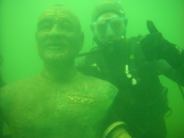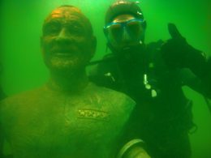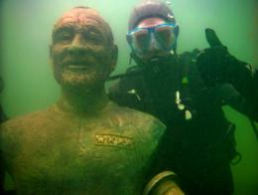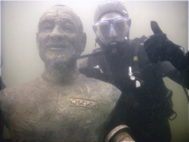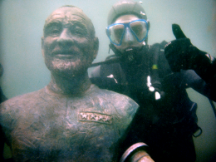

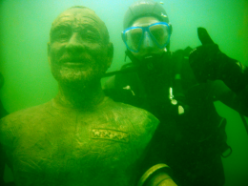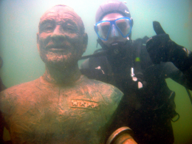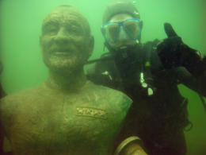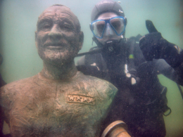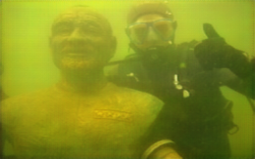

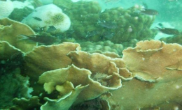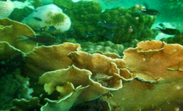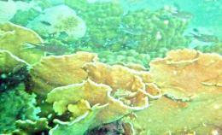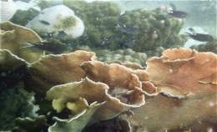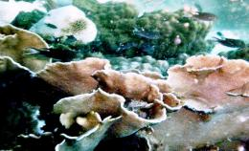

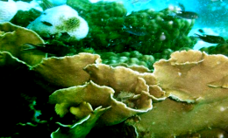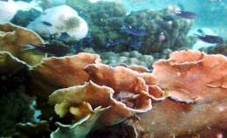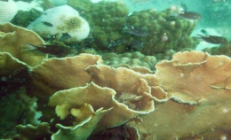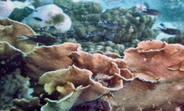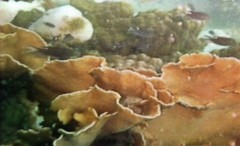

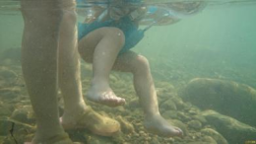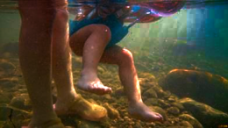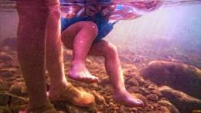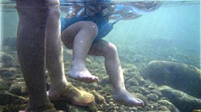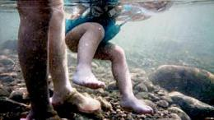

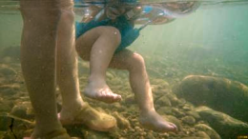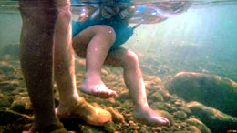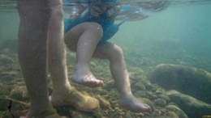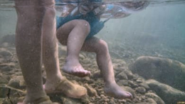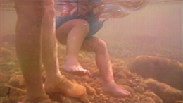

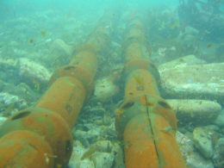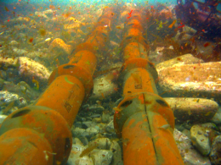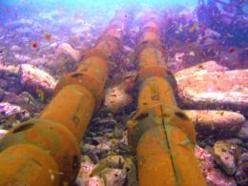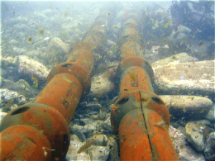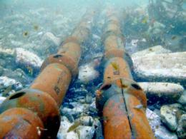

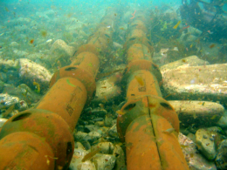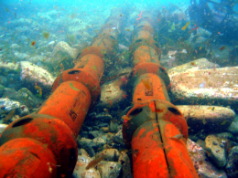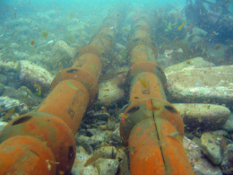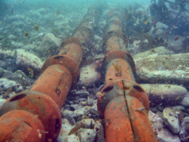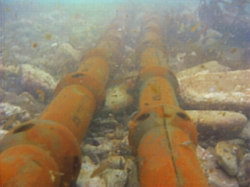

Figure 5: Comparison of the results of each algorithm

Each group of pictures from left to right and top to bottom are the original picture, UDCP[5], GDCP[6], Fusion-based[15], Retina-inspired[17], UIBLA[7], HE-prior[ 9], Red channel[8], Two-step[13], UGAN[19].

5 Summary and Outlook

Intelligent defogging and color restoration of underwater images are emerging research fields with great potential to help developers better explore the underwater environment. These methods are used to deal with degradations such as strong absorption, scattering, color distortion, and noise from artificial light sources to improve visibility and color balance. With the rapid development of image processing, underwater image processing has opened up many new research directions. In this article, we summarize a comprehensive review of current research. We first introduce the typical types of underwater image degradation, such as absorption, scattering, color distortion, and artificial light source interference. Subsequently, we outline the defogging and restoration algorithms for underwater images, which will help scholars better understand underwater image processing. We hope this review will be helpful for researchers and developers to understand the importance and great applications of underwater image processing. We expect that intelligent underwater image processing will make a great contribution to helping researchers better explore the underwater environment in the future.

References

1. JAFFE J S. Computer modeling and the design of optimal underwater imaging systems[J]. Journal of Oceanic Engineering,1990,15(2):101-111.
2. Koschmieder H. Theorie der horizontalen Sichtweite[J]. Beitrage zur Physik der freien Atmosphare, 1924: 33-53.
3. Narasimhan S G, Nayar S K. Contrast restoration of weather degraded images[J]. IEEE transactions on pattern analysis and machine intelligence, 2003, 25(6): 713-724.
4. He K, Sun J, Tang X. Single image haze removal using dark channel prior[J]. IEEE transactions on pattern analysis and machine intelligence, 2010, 33(12): 2341-2353.
5. Drews P, Nascimento E, Moraes F, et al. Transmission estimation in underwater single images[C]//Proceedings of the IEEE international conference on computer vision workshops. 2013: 825-830.
6. Peng Y T, Cao K, Cosman P C. Generalization of the dark channel prior for single image restoration[J]. IEEE Transactions on Image Processing, 2018, 27(6): 2856-2868.
7. Peng Y T, Cosman P C. Underwater image restoration based on image blurriness and light absorption[J]. IEEE transactions on image processing, 2017, 26(4): 1579-1594.
8. Galdran A, Pardo D, Picón A, et al. Automatic red-channel underwater image restoration[J]. Journal of Visual Communication and Image Representation, 2015, 26: 132-145.
9. Li C Y, Guo J C, Cong R M, et al. Underwater image enhancement by dehazing with minimum information loss and histogram distribution prior[J]. IEEE Transactions on Image Processing, 2016, 25(12): 5664-5677.
10. 张懿，刘旭，李海峰．自适应图像直方图均衡算法[J]．浙江大学学报(工学版)，2007,41(4):630-633.
11. ZUIDERVELD K. Contrast limited adaptive histogram equalization[M]//Graphics Gems IV. Academic Press Professional,Inc.,1994:474-485.
12. Iqbal K, Odetayo M, James A, et al. Enhancing the low quality images using unsupervised colour correction method[C]//2010 IEEE International Conference on Systems, Man and Cybernetics. IEEE, 2010: 1703-1709.
13. Fu X, Fan Z, Ling M, et al. Two-step approach for single underwater image enhancement[C]//2017 International Symposium on Intelligent Signal Processing and Communication Systems (ISPACS). IEEE, 2017: 789-794.
14. Liang Z, Wang Y, Ding X, et al. Single underwater image enhancement by attenuation map guided color correction and detail preserved dehazing[J]. Neurocomputing, 2021, 425: 160-172.
15. Ancuti C O, Ancuti C, De Vleeschouwer C, et al. Color balance and fusion for underwater image enhancement[J]. IEEE Transactions on image processing, 2017, 27(1): 379-393.
16. LAND E H,MCCANN J. Lightness and retinex theory[J].Journal of the Optical Society of America,1971,61(1):1-11.
17. Gao S B, Zhang M, Zhao Q, et al. Underwater image enhancement using adaptive retinal mechanisms[J]. IEEE Transactions on Image Processing, 2019, 28(11): 5580-5595.
18. Li J, Skinner K A, Eustice R M, et al. WaterGAN: Unsupervised generative network to enable real-time color correction of monocular underwater images[J]. IEEE Robotics and Automation letters, 2017, 3(1): 387-394.
19. Fabbri C, Islam M J, Sattar J. Enhancing underwater imagery using generative adversarial networks[C]//2018 IEEE International Conference on Robotics and Automation (ICRA). IEEE, 2018: 7159-7165.
20. Fabbri C, Islam M J, Sattar J. Enhancing underwater imagery using generative adversarial networks[C]//2018 IEEE International Conference on Robotics and Automation (ICRA). IEEE, 2018: 7159-7165.
21. Li C, Anwar S, Porikli F. Underwater scene prior inspired deep underwater image and video enhancement[J]. Pattern Recognition, 2020, 98: 107038.
22. Wang S, Ma K, Yeganeh H, et al. A patch-structure representation method for quality assessment of contrast changed images[J]. IEEE Signal Processing Letters, 2015, 22(12): 2387-2390.
23. Panetta K, Gao C, Agaian S. Human-visual-system-inspired underwater image quality measures[J]. IEEE Journal of Oceanic Engineering, 2015, 41(3): 541-551.